**AEC SPORTS CLUB OFFICIAL WEBSITE DESIGN**

**A Mini Project report Submitted**

**in Partial Fulfilment of the Requirements**

**for the Degree of**

**BACHELOR OF TECHNOLOGY**

**In**

**Computer Science & Engineering**

**By**

**Kaushal Maurya**

**2000010100027**

**CSE 3rd Year**

**Under the Supervision of**

**MR. Kamlesh Deshmukh**

**Assistant professor**



**ANAND ENGINEERING COLLEGE, AGRA**

**ABDUL KALAM TECHNICAL UNIVERSITY**

**LUCKNOW**

**December, 2022**

**TABLE OF CONTENTS**

Page No.

Certificate ii

Abstract iii

Acknowledgment iv

**CHAPTER 1: INTRODUCTION**

**CHAPTER 2: LITERATURE REVIEW**

* 1. **FAVICON**
  2. **NAVIGATION BAR**
  3. **BANNER**
  4. **BUTTON**
  5. **IMAGE GALLERY**
  6. **EMBED CODE FACILITY**
  7. **MAIL TO**

**CHAPTER 3: CONTENTS**

**3.1 HOMEPAGE HTML CODE**

**3.2 HOMEPAGE CSS CODE**

**3.3 LOGIN PAGE HTML CODE**

**3.4 LOGIN PAGE CSS CODE**

**4: CONCLUSION REFERENCE**

**Anand Engineering College, Keetham**

**Department of Computer Science & ENGINEERING**

**CERTIFICATE**



This is to certify that the mini project entitled, “**AEC SPORTS CLUB OFFICIAL WEBSITE DESIGN**”, which is being submitted here for the award of partial fulfilment of B.Tech degree is the result of the work completed by **Kaushal Maurya [2000010100027]** under my supervision and guidance within the institute and the same is the initiative taken by Institute / University for career growth of the student.

**Mini Project Co-ordinator**

MR. KAMLESH DESHMUKH

(Assistant professor)

**ACKNOWLEDGEMENT**

I take this opportunity to express a deep sense of gratitude towards my guide **MR KAMLESH DESHMUKH SIR**, for providing excellent guidance, encouragement and inspiration throughout the project. Over and above this, small queries on my part were constantly addressed and taken up by them with the cross functional team on a regular basis which helped all the members to see the mini project come through. I would also like to thank **MR. VINAY KUMAR SINGH**

**[ Head Of Department CSE ]** for their valuable suggestions and helpful discussions.

Heartfelt gratitude deserves to be expressed towards **MR. KAMLESH DESHMUKH SIR** for constantly enriching the seminar and various systems in place at different levels, which allowed me to understand the context and scope of this seminar, as well as its importance.

I am also grateful to the friends at worked place that provided a completely stress-free working environment throughout the tenure of the seminar.

**KAUSHAL MAURYA**

**[ 2000010100027 ]**

**B.Tech CSE 3rd Year**

**Introduction**

The motive of designing **aec sports club official** webpage to show how easy it is to make a proper website. Now the times comes where Website design is very normal thing but this is only possible because of new automatic website generation techniques but without using this automation how can we design. Lets have a look of this website in the picture given below.

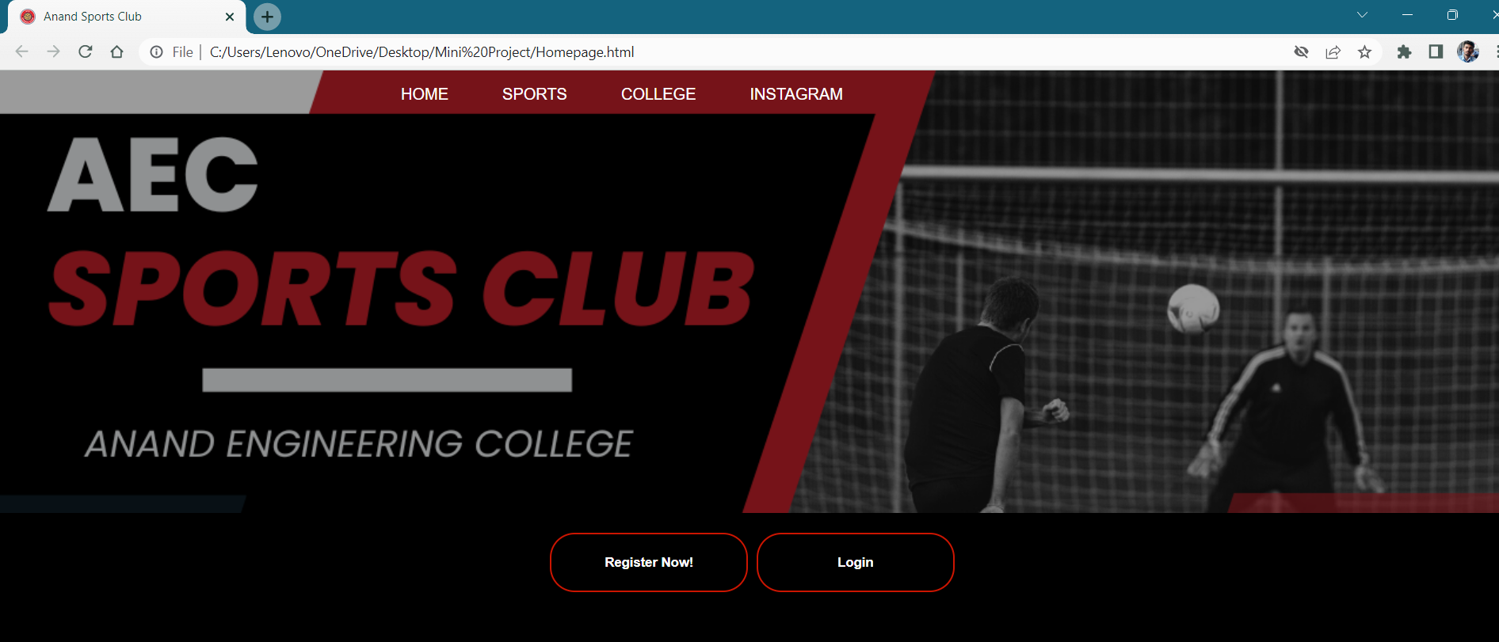

This website is design by HTML, CSS and JavaScipt.

Let me show the features of this websites in few parts.

**Literature Review**

1. **Favicon :-**

A favicon image is displayed to the left of the page title in the browser tab, like this:

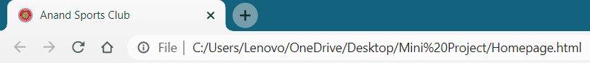

To add a favicon to your website, either save your favicon image to the root directory of your webserver, or create a folder in the root directory called images, and save your favicon image in this folder. A common name for a favicon image is "favicon.ico".

Next, add a <link> element to your "index.html" file, after the <title> element, like this:

1. **Navigation Bar :-**

Navigation bar is used to make thing easy for user to find their data Designing a working navigation bar with the help of <div> tags and <ul> <li> tags.

The <div> tag defines a division or a section in an HTML document.

The <div> tag is used as a container for HTML elements - which is then styled with CSS or manipulated with JavaScript.

The <div> tag is easily styled by using the class or id attribute.

Any sort of content can be put inside the <div> tag!

The <ul> tag defines an unordered (bulleted) list.

Use the <ul> tag together with the [<li>](https://www.w3schools.com/tags/tag_li.asp) tag to create unordered lists.



Every element of navigation bar contain a link to new webpage by using anchor tag. It is used to jump to other webpage.

Let me show it by clicking on college I am jump to aecagra.edu.in official website of our college.

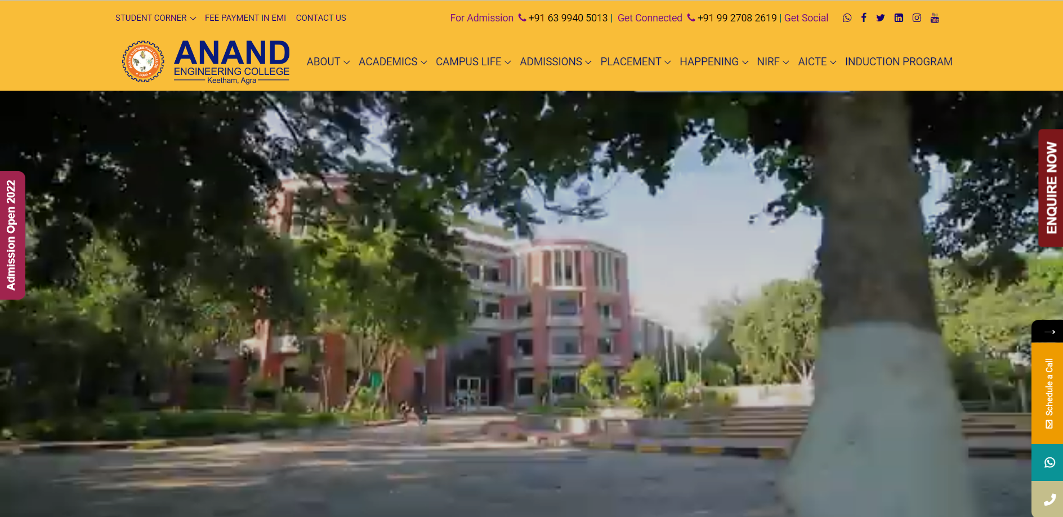

 In this navigation bar a animation technique is also given. By the use of **Hover** and  **After** this effect has been possible when you put the cursor on the anchors .



In this image you can see college anchor there is an underline when I puted the cursor on it.

1. **Banner :-**

A Banner is used to give a best view of your website an make it easy to understand by user. Using a <div> tag and <img> tag we can add a image in your webpage.



For example <img src=”image.jpg”>

1. **Buttons :-**

The buttons in html are used to do some particular task. Here we are attaching a link in both the buttons. For example if we press on register button it will go to a google form given in the fig and if we press login then the link goes to login page given in fig. <button> tag are used to create button in HTML.

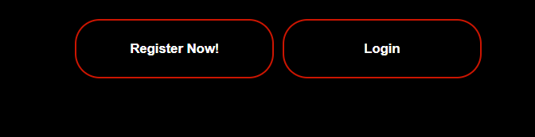

Fig 4.1

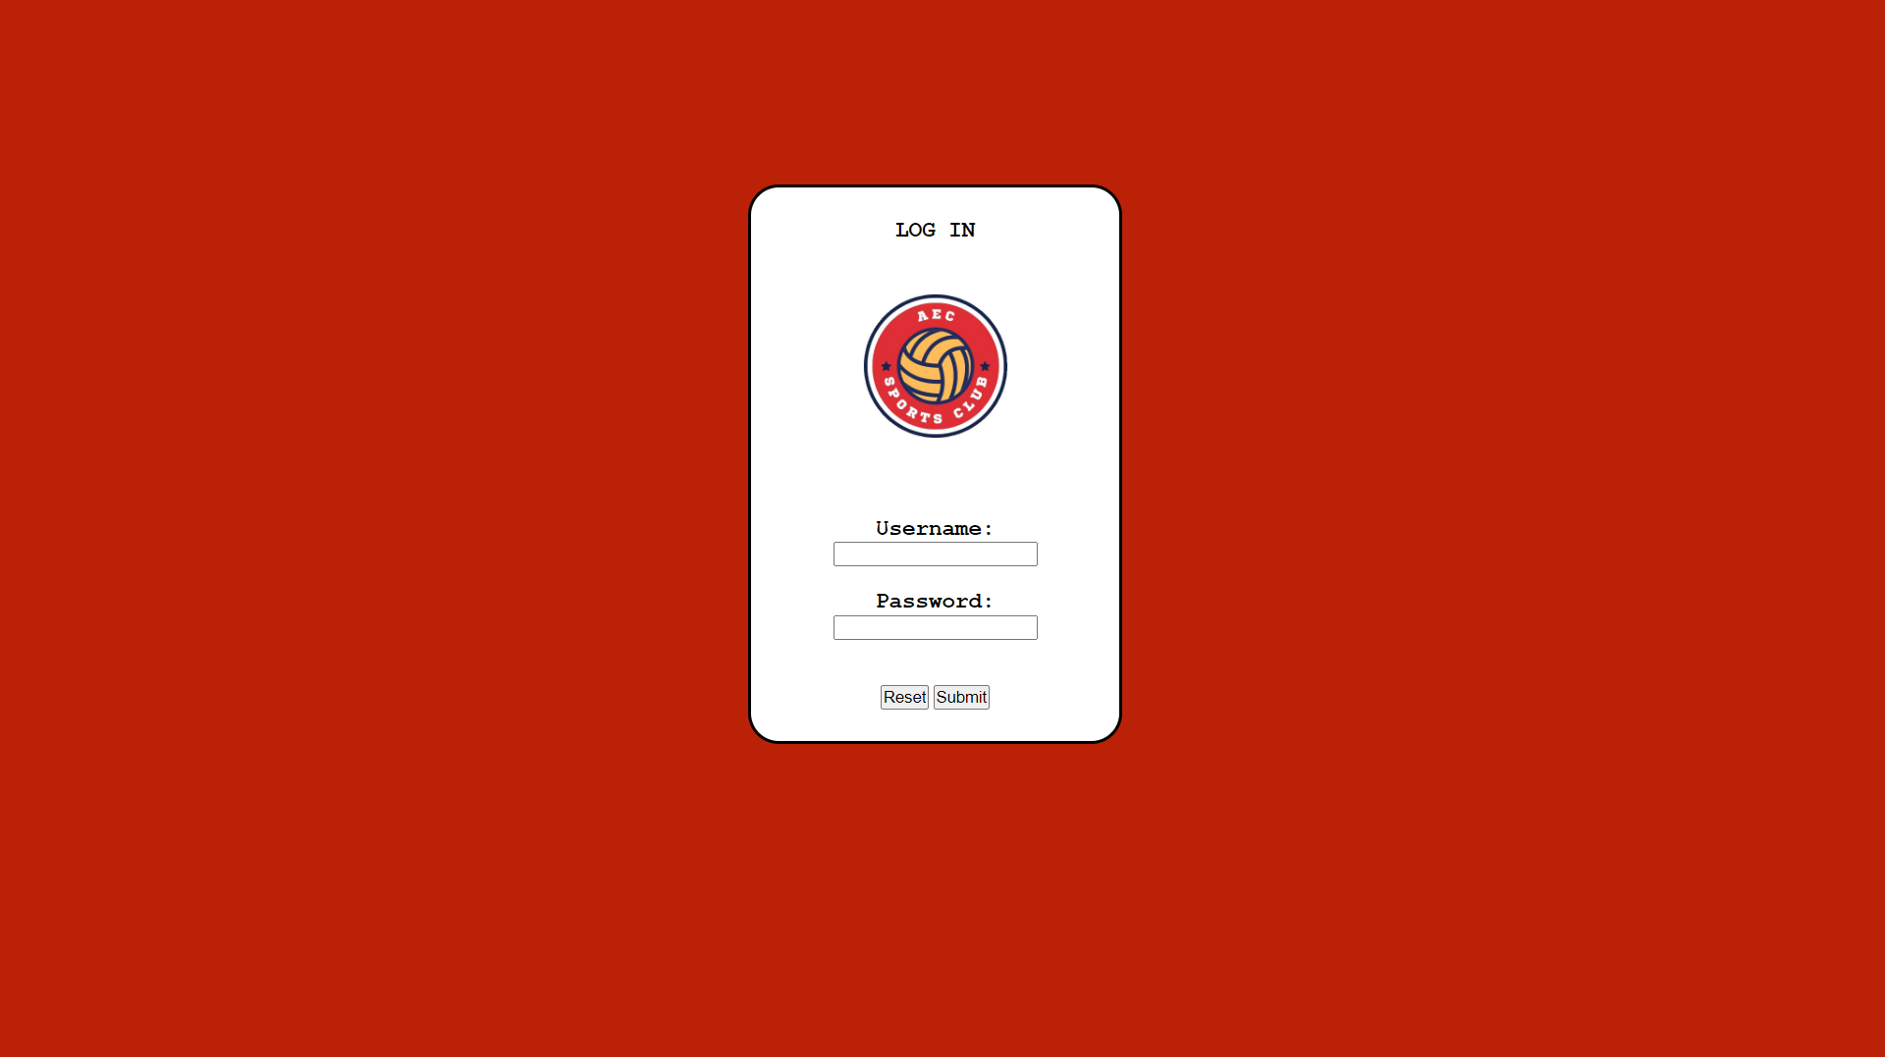

Fig 4.2

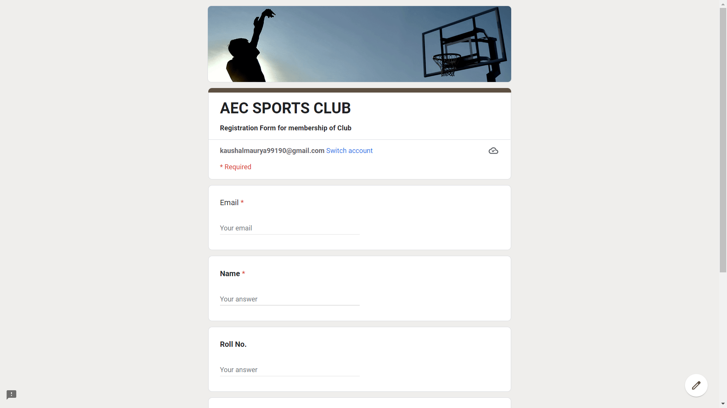

Fig 4.3

1. **Image Gallery :-**

Most of the image gallery are designed by using HTML and CSS.

Here we used CSS to maintain the look of the gallery.

Most of the role is done by padding and margin after that we used height and width.

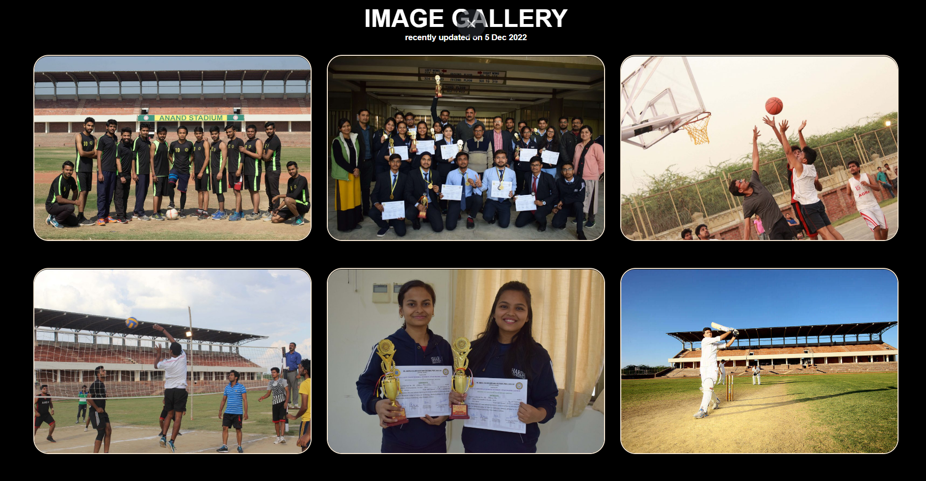

1. **Embed codes facility :-**

I used embed code facilities given by many website using <iframe> tag in html. For example youtube and instragram give his own embed code to add their features in your own website given in figures.

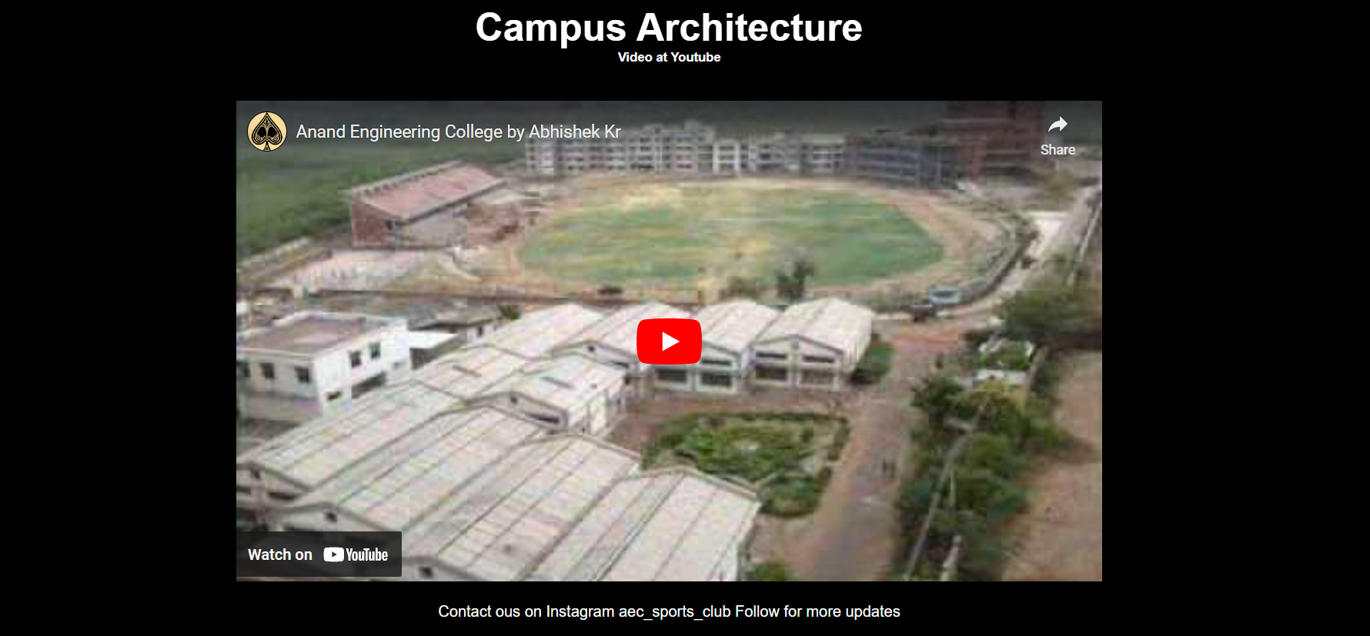

Fig 6.1

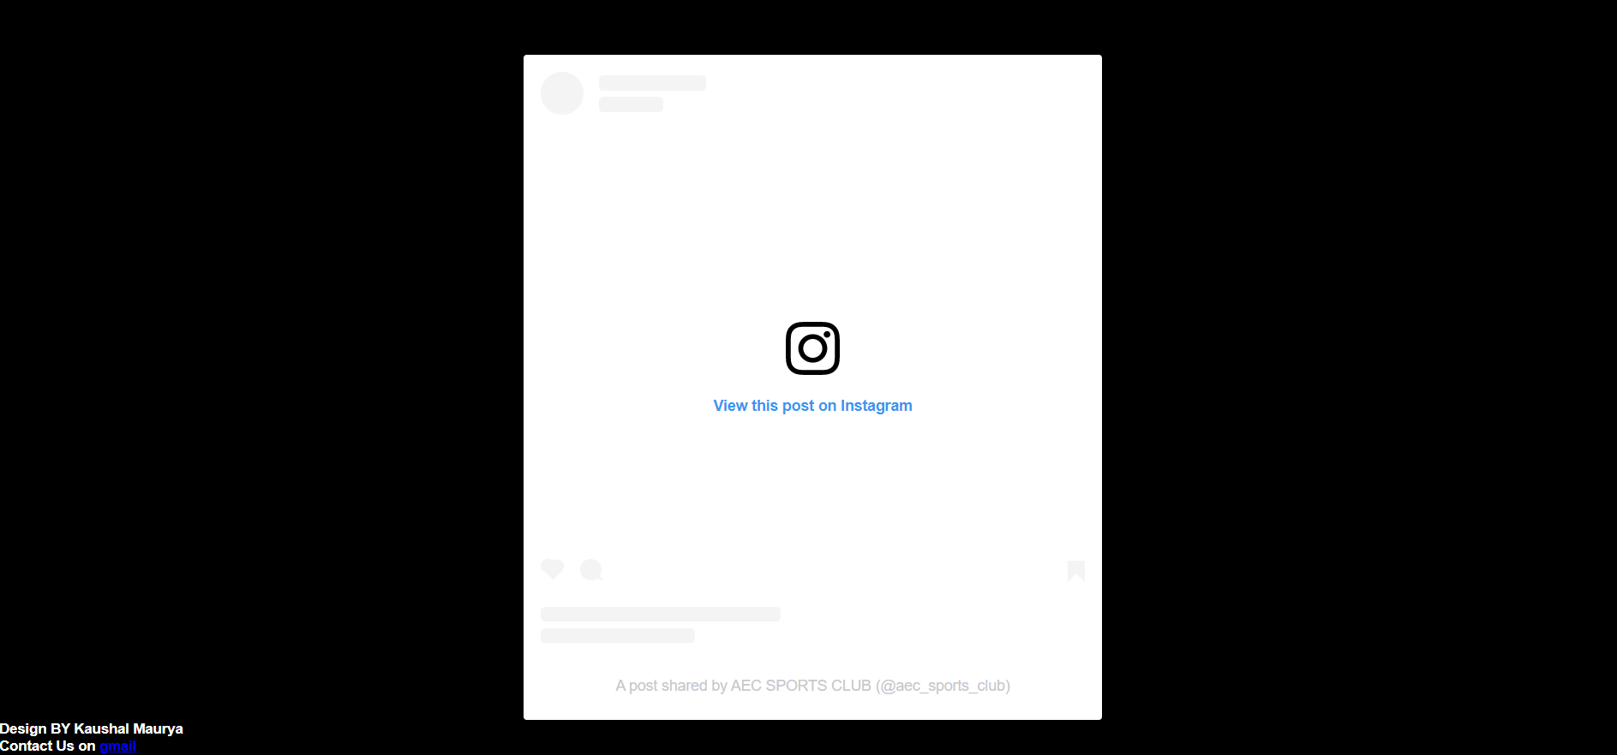

Fig 6.2

1. **Mail to :-**

It is quit easier to direct mail by clicking on text. It is done by <a> hyperlink tag. It reduce the time of mailing to someone and make it easier to visitor.

**Contents**

**HOMEPAGE HTML CODE:**

<!DOCTYPE html>

<html>

    <head>

        <title>Anand Sports Club</title>

        <link rel="stylesheet" href="Mycss.css">

        <link rel="icon" type="image/x-icon" href="LOGO.png">

    </head>

    <body>

        <div class="banner" >

            <div class="navbar">

                <ul>

                    <li><a href="Homepage.html">Home</a></li>

                    <li><a href="infra.html">Sports</a></li>

                    <li><a href="https://aecagra.edu.in/">College</a></li>

                    <li><a href="https://www.instagram.com/aec_sports_club/">Instagram</a></li>

                </ul>

            </div>

        </div>

        <center>

        <div class="content">

            <button type="button" onclick="document.location='https://forms.gle/YRDJHKaJgxtCjmWN9'">Register Now!</button>

            <button type="button" onclick="document.location='Login.html'">Login</button>

        </div></center>

        <div class="card">

            <br>

            <br>

            <br>

            <h2>IMAGE GALLERY</h2>

            <h5>recently updated on 5 Dec 2022</h5>

            <div class="fakeimg" ">

                <img src="anand-campus-sports-1024x683.jpg">

                <img src="Img1.jpg">

                <img src="img2.jpg">

                <img src="img3.jpg">

                <img src="img4.jpg  ">

                <img src="img5.jpeg">

                <img src="img6.jpg">

                <img src="img7.jpg">

                <img src="img8.jpg">

            </div>

        <div class="body1">

            <br>

            <br>

            <h2>Campus Architecture</h2>

            <h5>Video at Youtube</h5>

            <br>

            <br>

                <iframe width="900" height="500" src="https://www.youtube.com/embed/UMEF_2BoI4M" title="YouTube video player"

                frameborder="0" allow="accelerometer; autoplay; clipboard-write; encrypted-media; gyroscope; picture-in-picture"

                allowfullscreen></iframe>

                <br>

                <br>

                <p>Contact ous on Instagram aec_sports_club

                    Follow for more updates

                </p>

                <br>

                <br>

            </div>

            <br>

            <center>

                <div class="insta">

                    <blockquote class="instagram-media" data-instgrm-captioned data-instgrm-permalink="https://www.instagram.com/p/Cki-CBjqDKb/?utm_source=ig_embed&amp;utm_campaign=loading" data-instgrm-version="14" style=" background:#FFF; border:0; border-radius:3px; box-shadow:0 0 1px 0 rgba(0,0,0,0.5),0 1px 10px 0 rgba(0,0,0,0.15); margin: 1px; max-width:540px; min-width:326px; padding:0; width:99.375%; width:-webkit-calc(100% - 2px); width:calc(100% - 2px);"><div style="padding:16px;"> <a href="https://www.instagram.com/p/Cki-CBjqDKb/?utm_source=ig_embed&amp;utm_campaign=loading" style=" background:#FFFFFF; line-height:0; padding:0 0; text-align:center; text-decoration:none; width:100%;" target="_blank"> <div style=" display: flex; flex-direction: row; align-items: center;"> <div style="background-color: #F4F4F4; border-radius: 50%; flex-grow: 0; height: 40px; margin-right: 14px; width: 40px;"></div> <div style="display: flex; flex-direction: column; flex-grow: 1; justify-content: center;"> <div style=" background-color: #F4F4F4; border-radius: 4px; flex-grow: 0; height: 14px; margin-bottom: 6px; width: 100px;"></div> <div style=" background-color: #F4F4F4; border-radius: 4px; flex-grow: 0; height: 14px; width: 60px;"></div></div></div><div style="padding: 19% 0;"></div> <div style="display:block; height:50px; margin:0 auto 12px; width:50px;"><svg width="50px" height="50px" viewBox="0 0 60 60" version="1.1" xmlns="https://www.w3.org/2000/svg" xmlns:xlink="https://www.w3.org/1999/xlink"><g stroke="none" stroke-width="1" fill="none" fill-rule="evenodd"><g transform="translate(-511.000000, -20.000000)" fill="#000000"><g><path d="M556.869,30.41 C554.814,30.41 553.148,32.076 553.148,34.131 C553.148,36.186 554.814,37.852 556.869,37.852 C558.924,37.852 560.59,36.186 560.59,34.131 C560.59,32.076 558.924,30.41 556.869,30.41 M541,60.657 C535.114,60.657 530.342,55.887 530.342,50 C530.342,44.114 535.114,39.342 541,39.342 C546.887,39.342 551.658,44.114 551.658,50 C551.658,55.887 546.887,60.657 541,60.657 M541,33.886 C532.1,33.886 524.886,41.1 524.886,50 C524.886,58.899 532.1,66.113 541,66.113 C549.9,66.113 557.115,58.899 557.115,50 C557.115,41.1 549.9,33.886 541,33.886 M565.378,62.101 C565.244,65.022 564.756,66.606 564.346,67.663 C563.803,69.06 563.154,70.057 562.106,71.106 C561.058,72.155 560.06,72.803 558.662,73.347 C557.607,73.757 556.021,74.244 553.102,74.378 C549.944,74.521 548.997,74.552 541,74.552 C533.003,74.552 532.056,74.521 528.898,74.378 C525.979,74.244 524.393,73.757 523.338,73.347 C521.94,72.803 520.942,72.155 519.894,71.106 C518.846,70.057 518.197,69.06 517.654,67.663 C517.244,66.606 516.755,65.022 516.623,62.101 C516.479,58.943 516.448,57.996 516.448,50 C516.448,42.003 516.479,41.056 516.623,37.899 C516.755,34.978 517.244,33.391 517.654,32.338 C518.197,30.938 518.846,29.942 519.894,28.894 C520.942,27.846 521.94,27.196 523.338,26.654 C524.393,26.244 525.979,25.756 528.898,25.623 C532.057,25.479 533.004,25.448 541,25.448 C548.997,25.448 549.943,25.479 553.102,25.623 C556.021,25.756 557.607,26.244 558.662,26.654 C560.06,27.196 561.058,27.846 562.106,28.894 C563.154,29.942 563.803,30.938 564.346,32.338 C564.756,33.391 565.244,34.978 565.378,37.899 C565.522,41.056 565.552,42.003 565.552,50 C565.552,57.996 565.522,58.943 565.378,62.101 M570.82,37.631 C570.674,34.438 570.167,32.258 569.425,30.349 C568.659,28.377 567.633,26.702 565.965,25.035 C564.297,23.368 562.623,22.342 560.652,21.575 C558.743,20.834 556.562,20.326 553.369,20.18 C550.169,20.033 549.148,20 541,20 C532.853,20 531.831,20.033 528.631,20.18 C525.438,20.326 523.257,20.834 521.349,21.575 C519.376,22.342 517.703,23.368 516.035,25.035 C514.368,26.702 513.342,28.377 512.574,30.349 C511.834,32.258 511.326,34.438 511.181,37.631 C511.035,40.831 511,41.851 511,50 C511,58.147 511.035,59.17 511.181,62.369 C511.326,65.562 511.834,67.743 512.574,69.651 C513.342,71.625 514.368,73.296 516.035,74.965 C517.703,76.634 519.376,77.658 521.349,78.425 C523.257,79.167 525.438,79.673 528.631,79.82 C531.831,79.965 532.853,80.001 541,80.001 C549.148,80.001 550.169,79.965 553.369,79.82 C556.562,79.673 558.743,79.167 560.652,78.425 C562.623,77.658 564.297,76.634 565.965,74.965 C567.633,73.296 568.659,71.625 569.425,69.651 C570.167,67.743 570.674,65.562 570.82,62.369 C570.966,59.17 571,58.147 571,50 C571,41.851 570.966,40.831 570.82,37.631"></path></g></g></g></svg></div><div style="padding-top: 8px;"> <div style=" color:#3897f0; font-family:Arial,sans-serif; font-size:14px; font-style:normal; font-weight:550; line-height:18px;">View this post on Instagram</div></div><div style="padding: 12.5% 0;"></div> <div style="display: flex; flex-direction: row; margin-bottom: 14px; align-items: center;"><div> <div style="background-color: #F4F4F4; border-radius: 50%; height: 12.5px; width: 12.5px; transform: translateX(0px) translateY(7px);"></div> <div style="background-color: #F4F4F4; height: 12.5px; transform: rotate(-45deg) translateX(3px) translateY(1px); width: 12.5px; flex-grow: 0; margin-right: 14px; margin-left: 2px;"></div> <div style="background-color: #F4F4F4; border-radius: 50%; height: 12.5px; width: 12.5px; transform: translateX(9px) translateY(-18px);"></div></div><div style="margin-left: 8px;"> <div style=" background-color: #F4F4F4; border-radius: 50%; flex-grow: 0; height: 20px; width: 20px;"></div> <div style=" width: 0; height: 0; border-top: 2px solid transparent; border-left: 6px solid #f4f4f4; border-bottom: 2px solid transparent; transform: translateX(16px) translateY(-4px) rotate(30deg)"></div></div><div style="margin-left: auto;"> <div style=" width: 0px; border-top: 8px solid #F4F4F4; border-right: 8px solid transparent; transform: translateY(16px);"></div> <div style=" background-color: #F4F4F4; flex-grow: 0; height: 12px; width: 16px; transform: translateY(-4px);"></div> <div style=" width: 0; height: 0; border-top: 8px solid #F4F4F4; border-left: 8px solid transparent; transform: translateY(-4px) translateX(8px);"></div></div></div> <div style="display: flex; flex-direction: column; flex-grow: 1; justify-content: center; margin-bottom: 24px;"> <div style=" background-color: #F4F4F4; border-radius: 4px; flex-grow: 0; height: 14px; margin-bottom: 6px; width: 224px;"></div> <div style=" background-color: #F4F4F4; border-radius: 4px; flex-grow: 0; height: 14px; width: 144px;"></div></div></a><p style=" color:#c9c8cd; font-family:Arial,sans-serif; font-size:14px; line-height:17px; margin-bottom:0; margin-top:8px; overflow:hidden; padding:8px 0 7px; text-align:center; text-overflow:ellipsis; white-space:nowrap;"><a href="https://www.instagram.com/p/Cki-CBjqDKb/?utm_source=ig_embed&amp;utm_campaign=loading" style=" color:#c9c8cd; font-family:Arial,sans-serif; font-size:14px; font-style:normal; font-weight:normal; line-height:17px; text-decoration:none;" target="_blank">A post shared by AEC SPORTS CLUB (@aec_sports_club)</a></p></div></blockquote> <script async src="//www.instagram.com/embed.js"></script>

                    </div>

            </center>

            <div class="about" align="left">

                <h5>Design BY Kaushal Maurya</h5>

                <h5>Contact Us on <a href="mailto: kaushalmaurya99190@gmail.com">gmail</a></h5>

            </div>

    </body>

</html>

**HOME PAGE CSS CODE:**

*{

  margin: 0;

  padding: 0;

  font-family: sans-serif;

}

.banner{

    width: 100%;

    height: 60vh;

    background-image: linear-gradient(rgba(0, 0, 0, 0.393),rgba(0,0,0,0.393)),

    url(Red\ Black\ Modern\ Sports\ YouTube\ Thumbnail.png);

    background-size: cover;

}

.navbar{

    width: 50%;

    margin: auto;

    padding: 15px 0;

    display: flex;

}

.navbar ul li{

    list-style: none;

    display: inline-block;

    margin:0 25px;

    position: relative;

}

.navbar ul li a{

    text-decoration: none;

    color: #fff;

    text-transform: uppercase;

}

.navbar ul li::after{

    content: "";

    height: 3px;

    width: 0;

    background: #000000;

    position: absolute;

    left: 0;

    bottom: -7px;

    transition: 1s;

}

.navbar ul li:hover::after{

    width: 50px;

}

.content{

    background-color: rgb(0, 0, 0);

    align-items:center;

}

.content a{

    text-decoration: none;

    color: #fff;

    text-transform: uppercase;

}

button{

    width: 200px;

    padding: 20px 0;

    text-align: center;

    margin: 20px 2px;

    border-radius: 25px;

    font-weight: bold;

    border: 2px solid #cc1501;

    background: transparent;

    color: #fff;

    cursor: pointer;

    position: relative;

    overflow:hidden;

}

.span{

    background: #cc1501;

    height: 100%;

    width: 100%;

    border-radius: 25px;

    position: absolute;

    left: 0%;

    bottom: 0%;

}

.body1{

    background-color: #000000;

    text-align: center;

}

.body1 h2{

    font-size: 50px;

}

.card{

    text-align: center;

    background: #000000;

}

.card h2{

    color: #fff;

    font-size: 40px;

}

.card h5{

    color: #fff;

}

.fakeimg img{

    width: 450px;

    height: 300px;

    margin: 20px 10px;

    border-radius: 25px;

    border-color: antiquewhite;

    border-style: solid;

    border-width: 2px;

}

.body1 p{

    color: #fff;}

**LOGIN PAGE HTML CODE:**

<!DOCTYPE html>

<html>

    <head>

        <title>aec login</title>

        <link rel="stylesheet" href="login.css">

        <link rel="icon" type="image/x-icon" href="LOGO.png">

    </head>

    <body>

        <div class="info">

            <p><b>LOG IN</b></p>

            <img src="LOGO.png">

            <br>

            <br>

            <center>

                <form>

                    <p><b>Username:</b></p>

                    <input type="text" name="Fname"><br><br>

                    <p><b>Password:</b></p>

                    <input type="password" name="pas">

                    <br>

                    <br>

                    <br>

                    <input type="reset" name="reset">

                    <input type="submit" name="submit"><br>

                </form>

            </center>

        </div>

    </body>

**LOGIN PAGE CSS CODE:**

*{

    margin: 0;

    padding: 0;

}

body{

    background-color:#ba2106

}

.info{

    background: white;

    width: 300px;

    padding: 25px 0;

    text-align: center;

    padding: 25px 0;

    border-style: inset;

    border-color: rgb(0, 0, 0);

    border-radius: 25px;

    position: relative;

    bottom: -150px;

    transform: translateY(50%);

    transform: translateX(200%);

}

.info img{

    background: white;

    margin: 20px 20px;

    padding: 20px 20px;

    width: 120px;

    height: 120px;

    align-items:center;

}

.info p{

    background: white;

    text-align: center;

    font-family: 'Courier New', Courier, monospace;

    font-size: large;

}

**REFFERENCES:**

1. I am taken help from given notes that are provided from Mr. Kamlesh Deshmukh Sir.
2. Web Technologies book written by Uttam K. Roy oxford higher education.
3. Site : https//javatpoint.com/
4. Site : https//w3resource.com/
5. Site : https//w3school.com/
6. Link: https://web.stanford.edu/group/csp/cs21/htmlcheatsheet.pdf.